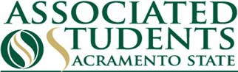

Effective 3/18/2020 until further notice, we can no longer offer services at our Business Office or Student Shop.
Please drop off all check requests & documentation at our ASI Children's Center on Friday 3/20/20 from 9:00 am - 4:00 pm.

For this week’s check run (3/16/20), Accounts Payable and Payroll checks will be available for pick-up this Friday (3/20/20) at the ASI Children's Center from 9:00 am-4:00 pm. Checks not picked up by 4:00 pm will be mailed-out to the address on file.

Effective the week of 3/23/2020, we will no longer offer Accounts Payable AND Payroll check pick-up services, ALL CHECKS WILL BE MAILED.
Also, due to the closure, we will no longer be offering in-person Cap & Gown sales. For online ordering of Cap & Gowns please visit: https://asi.csus.edu/post/graduation-supplies

